# Lab 8: Vapor Compression Refrigeration Cycle

Alia binti Mohd Zaki

3/24/2020

**1. Figure and Tables**

**Figure 1a.** Plot of the ambient air temperature (Tamb), refrigerant temperature at the condenser outlet & expansion inlet valve (T3), refrigerant temperature at the expansion valve outlet & evaporator inlet (T4), air temperature exiting the condenser (Tc), and air temperature exiting the evaporator (Te) as functions of refrigerant mass flow rate (ṁ).

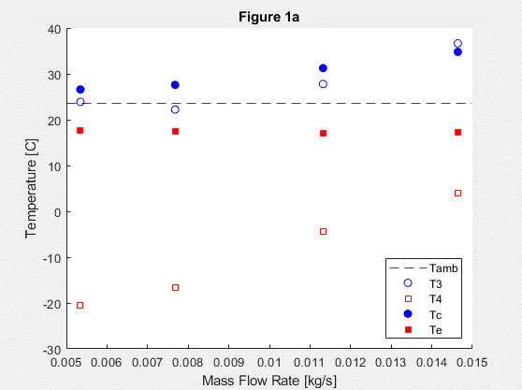

**Figure 1b.** Plot of the the specific energy terms (qL, qH, qloss and win) as a function of refrigerant mass flow rate (ṁ).

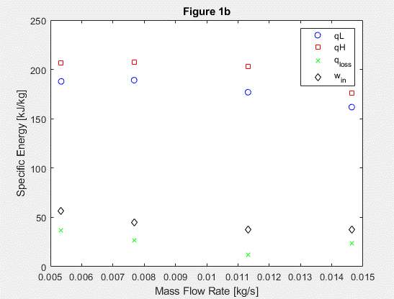

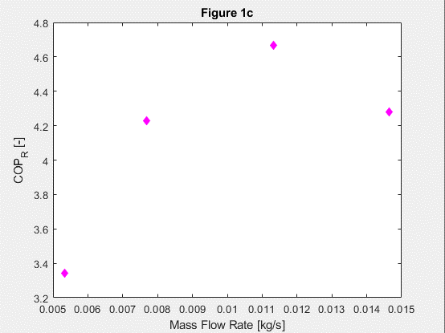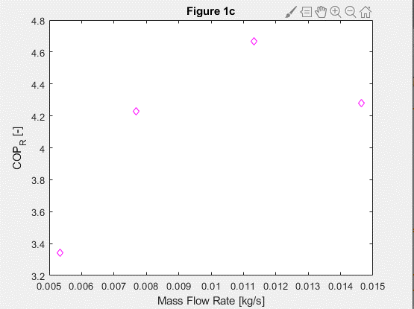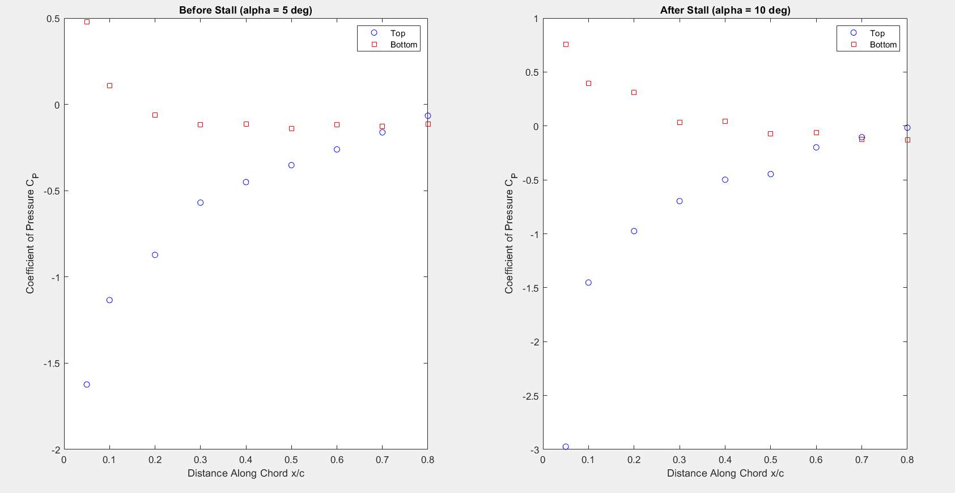

**Figure 1c.** Plot of the coeffiecient of pressure (COPR) as a function on refrigerant mass flow rate (ṁ).

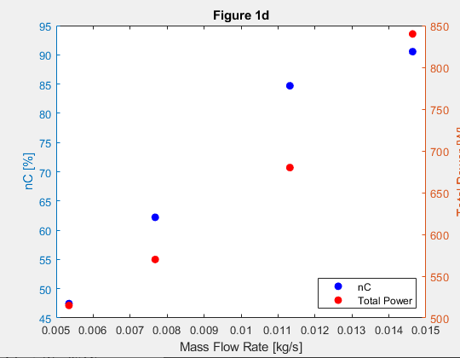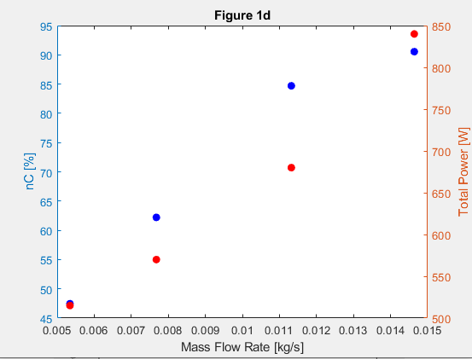

**Figure 1d.** Plot of the isentropic efficiency (ɳC) on the left y-axis in blue, markers also in blue, and the total electrical power supplied (Ẇ) on the right y-axis in red, markers also in red, as functions of mass flow rate (ṁ).

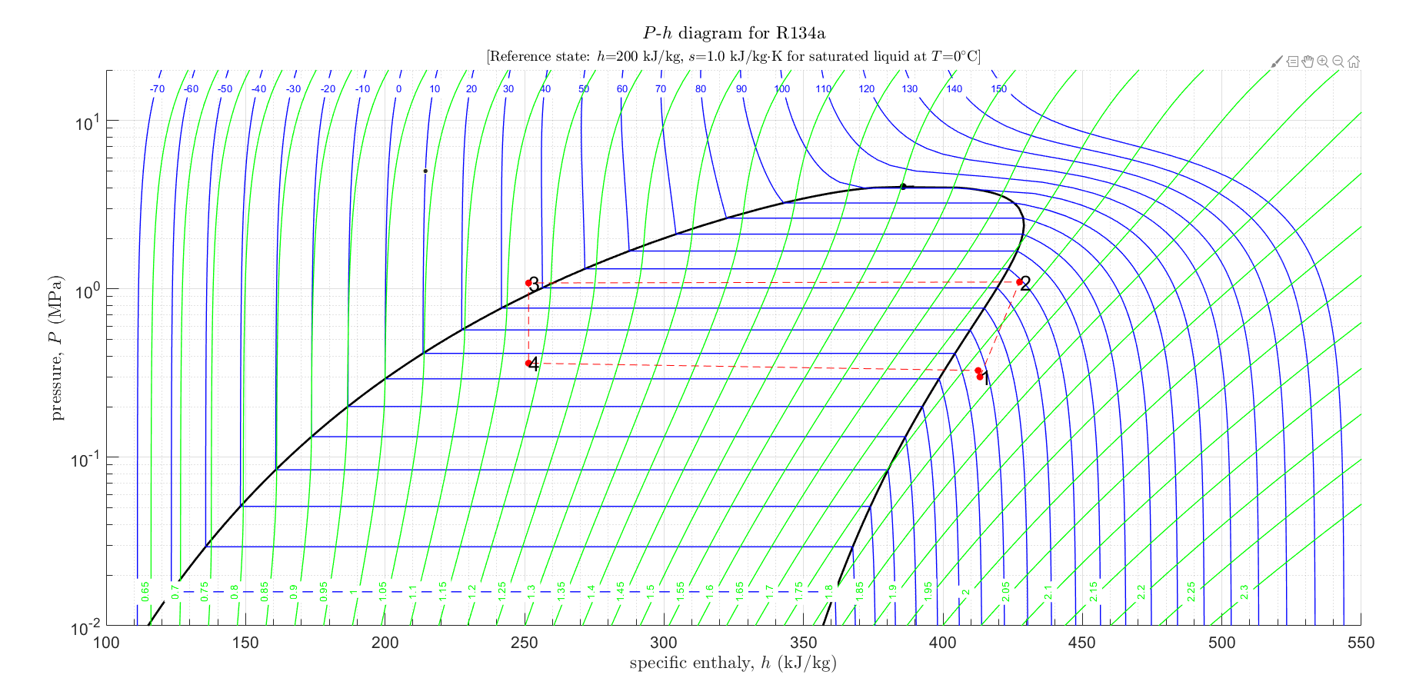

**Figure 1e.** Plot of the pressure as a function of specific enthalpy. The red markers represent the four states while the red dashed lines represent the process paths between the four states. The four states are also labelled 1, 2, 3, and 4.

**2. Short Answer Questions**

1. *List and explain the observed differences in the P-h diagrams between an ideal cycle (as depicted in Figure 2 and that obtained from your actual measurements. [4–6 sentences].*

The first noticeable difference is that at the first state, the refigerant is in vapor state in the actual cycle whereas in the ideal cycle, it is in the saturated vapor state. Secondly, at the third state, the refrigerant is in liquid state in the actual cycle while in the ideal cycle, it is in saturated liquid state. Another difference to note is that at the “fifth” state, which should be the equal to the first state to continue the cycle, the pressure is lower than that of the first state.

Other than that, the process path from the first state to the second state of the actual cycle is less steep than that of the ideal cycle. Lastly, it is assumed that the process path from state three to state four is isentropic in the actual cycle but in actuality, state four is not in mixed liquid/vapor state as shown in Figure 1c, it is in liquid state.

1. *Based on your results and your engineering judgment, at what flow rate should the refrigerator be run. Justify your answer. [3–4 sentences].*

Based on my results and engineering expertise of 0 years, the mass flow rate the refrigerator should be run at is 0.01132 kg/s. This flow rate yielded the highest coefficient of performance at 4.6, higher than that of the typical household refrigerator. This means that the specified mass flow rate is the most efficient at rejecting heat.

1. *Perform a brief literature search of vapor-compression refrigeration systems to determine how one can improve the coefficient of performance of an actual system. Describe at least one means of increasing COPR and explain how it works in terms of equation (10). Include one or more references from your literature search. [3–6 sentences].*

Astrain et al. created a device for the dissipation of heat, based on the principle of thermosyphon with phase change called the TSF. The experiment was conducted on a Peltier pellet the size of 40 x 40 mm. The TSF works to decrease the thermal resisteance between the hot side of a Peltier pellet and the ambient. It is found that that the TSF increased the COP by 26% at an ambient temperature of 293 K, improving by 36.5% at an ambient tempretaure of 303 K.

Reference:

<https://doi.org/10.1016/S1359-4311(03)00202-3>

P.S. I invite you to check out this totally legimate research article on how to increase COPR <https://www.ijser.org/researchpaper/Improve-the-cop-of-Vapor-compression-cycle-with-change-in-Evaporator-and-Condenser-pressure.pdf>